Free Youtube views for an unlimited number of your videos! Boost your video's popularity using their simple and free method! Or, buy Youtube views and other services here.

[ythunder.com](https://ythunder.com/) has free & open registrations.

Every day, [YouTube](https://ythunder.com/) generates billions of views as people watch hundreds of millions of hours of content. At this point, it has over one billion users. If those basic stats aren’t enough to convince you to establish a presence there, we’re not sure what will.Free Youtube views：[ythunder.com](https://ythunder.com/)

Simply creating videos doesn’t guarantee that you’ll get an audience. If you want to stand out on this platform, you may find it challenging to keep getting more views and subscribers on your channel. **If you want to get noticed, you have to get serious about promotion.**

Not sure where to start? Let’s take a look at 11 methods you can use to promote your channel and help you grow your numbers.

Start with your Titles

This is the first thing that people will see when they discover your video, along with your thumbnail. First and foremost, titles should be informative and attention grabbing.

Keep it simple, and remember that **most great titles are short and to the point.** Google shortens page titles at 66 characters so make sure you note that as well. You can also use tools like Google Adwords Keyword Planner for your titles so your video will rank higher for the search results that you care most about.

Tell your viewers why they should watch or how they can Free Youtube views：[ythunder.com](https://ythunder.com/)

benefit from watching your content through your title. Remember though, make it as short and concise as you can. If you type “Morning Yoga” on [YouTube](https://ythunder.com/), you’ll notice that those with the most views are videos with titles that explicitly tell viewers their benefits or intentions.

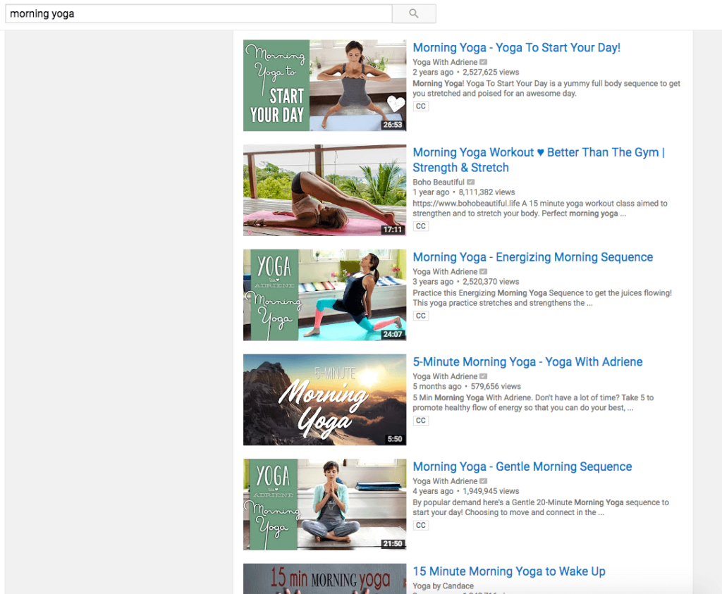

*Image credit:* [*YouTube*](https://ythunder.com/)

Create Custom Thumbnails

Thumbnails act as a preview to your video. Just like the video title, your thumbnail should be attention grabbing and compelling. Effective thumbnails usually include close-ups of faces, colored backgrounds, text overlays, and special attention to branding.

For example, take how Placester Inc creates the thumbnails of their ‘Marketing Academy Secrets’ videos. They have a uniform look, yet they’re attention grabbing, and also straight to the point. Their thumbnails create a strong sense of branding so that you’ll immediately know the video is from them.

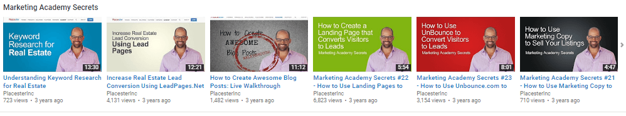

Create Playlists

The more videos you create and publish, the more difficult it will be for your viewers to find specific videos in your channel. The best way to organize this is to create playlists.

It will help to have a solid content strategy, so you know the themes you’ll be addressing and can make playlists right from the start. Add playlists as needed, as you create more and more videos.

[Buy YouTube Views](https://ythunder.com/) and Engagement

You can amplify your marketing strategies by purchasing [YouTube Views](https://ythunder.com/) and other signals of engagement such as likes, comments, and subscribers. **This is a great way to improve your social proof and make you appear more popular and credible**.

In the social media world, people be attracted to your channel and videos when they see how popular they are. You’ll draw people in, and if they like what they see they’ll subscribe. Voila! More subscribers, as easy as that.

Create A Video Series

You can create a recurring video series to entice your viewers with new content on a regular basis. It’s like creating your own TV series where fans will know to check your channel on a certain day or time for your new video.

It doesn’t have to be a weekly thing, it can be bi-weekly or monthly. **The important thing is to be consistent.** Come up with a creative name for your series that people will remember.

Gary Vaynerchuk’s [YouTube](https://ythunder.com/) channel is famous for its #AskGaryVee Show. Every week he does a video answering questions about marketing, social media, and entrepreneurship, and tons of people are tuning in to watch.

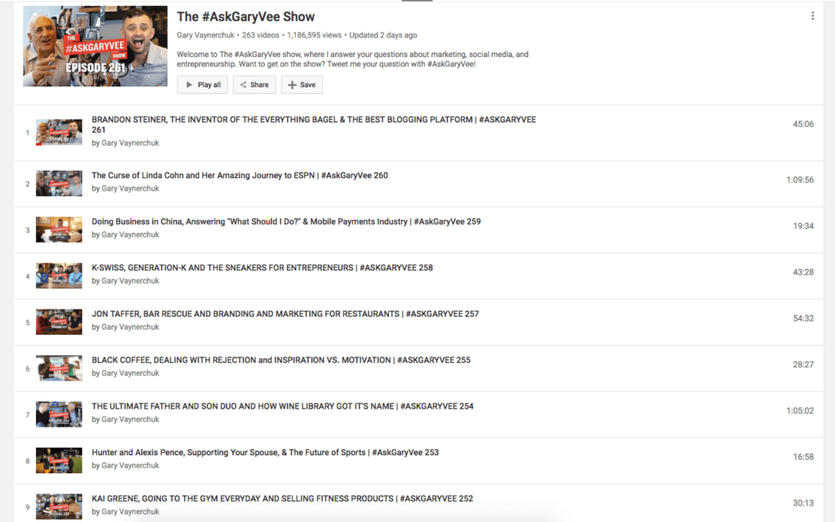

[YouTube](https://ythunder.com/) Giveaways and Contests

In the world of social media, followers love giveaways and prizes. If you want more people to subscribe and engage with your channel, host a [YouTube](https://ythunder.com/) contest or giveaway. To enter the running, you can ask your viewers to like your video, leave a comment, and subscribe to your channel.

As often as possible, **give away gifts that are related to your brand or better yet, use your own products.** You can also incorporate user-generated content as your entry requirements to really get people thinking, excited, and engaged.

Get Active in the [YouTube](https://ythunder.com/) Community

The [YouTube](https://ythunder.com/) community is composed of very active users. **It lives on interaction**. People are always talking, although some comment sections are not a great place to be.

One of the ways you can promote your channel is to actually join in on the conversations whenever possible (when they are positive). If someone leaves you a comment, acknowledge them and keep the conversation going.

Cross Promote your Videos

There are many ways you can promote your videos, and why not use videos themselves? You can reference an older video or an upcoming one in any of your clips, and leave a link in your description. You can also use [YouTube](https://ythunder.com/) cards and end cards to highlight your other videos.

Promote your [YouTube](https://ythunder.com/) videos on your different social media platforms like Twitter, Facebook, and Instagram. If you blog, look for ways you can embed your videos within your posts. Be creative and look for opportunities to cross promote between platforms whenever possible.

Enable Fan Finder

The Fan Finder Program, also known as Channel Ads, is a free way to use ads on [YouTube](https://ythunder.com/). It’s a feature that allows [YouTube](https://ythunder.com/) to display one of your videos as a pre-roll ad for free.

While Fan Finder is no longer directly accepting public applications, you still might be able to get into the program. It’s still worth a try since it won’t cost you a dime. All you have to do is go to your creator studio, select the Channel tab, and then Featured Content. From there, you can select your channel Ad and let the magic (hopefully) happen.

Work with Influencers

Consider partnering with influencers to promote your channel. There are many different ways you can collaborate, doing videos together or simply promoting each other in your videos.

**This will help both of you to reach out to a whole new audience.** Just keep in mind that your goals should be aligned so you’ll will be in a win-win situation.

[YouTube](https://ythunder.com/) star Lily Singh did a video with one of the most famous [YouTuber](https://ythunder.com/)s, Ryan Higa. While Lily herself is famous in the [YouTube](https://ythunder.com/) world, this is one of her most viewed videos at more than 12 million views. By teaming up, they become more attractive to both of their audiences.

Enable [YouTube](https://ythunder.com/) Ads

If you have the budget, you can run [YouTube](https://ythunder.com/) ads to promote your channel. There are a few different types of ad formats that you can use:

* **Display ads**: Ads that show up on the right-hand side bar of videos, and are only available on desktop.
* **Sponsored ads**: These get displayed within the relevant videos. You can use these cards to promote your products and other content.
* **Overlay ads**: Semi-transparent ads that are displayed at the bottom of the video.
* **Bumper ads**: Non-skippable ads that have to be watched before the video can be watched.
* **Skippable and Non-skippable ads**: Ads that show before, during, or after a video. Skippable ads can be skipped after 5 seconds, while non-skippable must be watched all the way through.

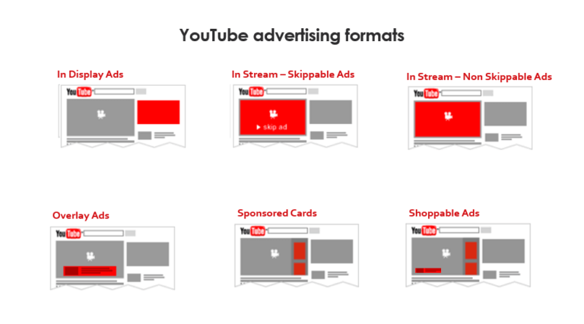

Boost Your Channel!

You can upload the best videos in the world but you’ll still need to spend some time promoting them as well. You want to get your channel and videos in front of as many viewers as possible, to take advantage of the exponential growth that can happen online.

**Promote your** [**YouTube**](https://ythunder.com/) **channel in a way that not only builds your reputation with your subscribers but also builds your social media community, so you have a strong, expanding base to work with.**

Marketing and promoting your [YouTube](https://ythunder.com/) channel takes effort, and you won’t build a massive following overnight. But remember, you can [buy YouTube Views](https://ythunder.com/) to help get your videos in front of more people, growing your channel quickly and efficiently. Combine this strategy with the tips we’ve mentioned above, and you’ll be unstoppable!



*Image credit: Giphy*

Date: *August 3, 2017* / Categories: *Explainer, Tips,* / Author: *Pamela*

Next

PreviousFree Youtube views for an unlimited number of your videos! Boost your video's popularity using their simple and free method! Or, buy Youtube views and other services here.

[ythunder.com](https://ythunder.com/) has free & open registrations.